Taking the Bread and the Cup
Prayer after Communion
Eternal God, we give you thanks for this holy mystery in which you have given yourself to us. We promise to extend ourselves to show hospitality to strangers. Grant that we may go into the world in the strength of your Spirit, to give ourselves for others. In the name of Jesus Christ our Lord. Amen
*Singing Our Faith # 702 “Sing with All the Saints in Glory”
*Blessing and Dismissal
*Postlude
Scatter to Serve God & Neighbor
Welcome to all! We gather to praise God for the innumerable blessings given to us and to grow deeper in the Spirit. Joyfully, let us lift our hearts to God.

Children and Their Safety are Important at Chestnut Hill UMC
We rejoice that as a church we are able to offer carefully planned, age appropriate care and activities for our children and youth.
Today, children ages 6 and above will stay in the sanctuary for worship.
The Nursery for infants up to age 6 is located in Classroom 101 (exit through the right side door at the front of the sanctuary, pass through “the Commons,” go through the double doors to the Education Building and follow the hallway to the
Nursery at the end of the hall on the left).

DIRECTORY OF CHESTNUT HILL UNITED METHODIST CHURCH
 | Sharma Lewis | Richmond Area Resident Bishop
 | Peter D. Weaver | Interim Bishop
 | Scott Davis | Lynchburg District Superintendent
 | Liz Ecklund | Minister
 | Vernie Barrow | Minister Emeritus
 | Monica Campbell | Administrative Assistant
 | Heather Wilson | Director of Music Ministry
 | Judy Martin | Bookkeeper
 | Judy Robertson | Lay Leader
 | Erin Ecklund | Nursery Supervisor


Chestnut Hill
United Methodist Church

Making disciples of Jesus Christ
for the transformation of the world.
You are welcome at Chestnut Hill UMC.

4660 Fort Avenue ~ Lynchburg, Virginia 24502
Church: 434-239-8423
Pastor’s Cell: 434-258-2934; Pastor’s Home: 434-319-5646
Email Pastor Liz: Pastorliz@aol.com
chestnuthillumc@comcast.net ~ on the web at chestnuthillumc.net
Find us on Facebook: Chestnut Hill United Methodist Church
Chestnut Hill United Methodist Church
10:30 a.m. ~ November 3, 2019 ~ Twenty-first Sunday after Pentecost
All Saints Sunday
Our ministry vision for the Virginia Annual Conference is “to be disciples of Jesus Christ who are lifelong learners, who influence others to serve.”
Welcome! Join us in worshiping God!
Welcome and Ministry Announcements
Welcome in the name of Christ our Lord. Please register your attendance,
printing your name, address, phone, and email, when the pew pad is passed to you.
Thank you for silencing cell phones as we gather to worship God.
Invocation
Prelude “Lord I’m Coming Home” arr. Moore
Call to Worship
I looked over Jordan, that river we all will eventually cross...
O Lord, what a vision.
I could see the saints singing and dancing.
I saw grandpa fishing in the Crystal Sea,
I heard grandma humming in the kitchen...
O Lord, what a vision.
There were countless others, all faithful disciples, gathered worshiping...
That old man who sang solos in the choir,
That young man whose life was cut short in that accident...
O Lord what a vision.
But the most amazing thing I saw as I looked over Jordan...
Yes? Yes?
Was the man standing in the shallows, smiling, saying
"Welcome home."
*Singing Our Faith # 711 “For All the Saints”
Morning Prayer
Almighty God, your people of all the ages live and praise you without ceasing. In our communion with you, we have communion with generations past and generations yet unborn. Before your throne we are one with a great multitude which no one could number, and in praising you we join with those from every nation. Grant to your church on earth

that as we celebrate the triumph of your saints in glory we may profit by their example and enter with them into the inexpressible joys you have prepared for those who love you, through Jesus Christ our Lord. Amen.
Prayer of Confession
Words of Assurance
Friends, hear this Good News: the love of God is beyond measure, and you are included in that love. Know that you are forgiven and thus freed to love and serve. Alleluia! Amen
Choral Anthem “Well Done, Good and Faithful Servant” Choplin
Prayer for Illumination Carolyn Stewart
Lord, open our hearts and minds by the power of your Holy Spirit, that, as the Scriptures are read and your Word proclaimed, we may hear with joy what you say to us today. Amen.
Affirmation of Faith #882 “The Apostles’ Creed” Carolyn Stewart
Gospel Lesson Luke 6:20-31 (NRSV) Carolyn Stewart
The Word of God for the people of God.
Thanks be to God.
Singing Our Faith # 2036 “Give Thanks”
The Good News “Remembering”
The Giving of God’s Tithes and Our Gifts
Prayer of Thanksgiving
Offertory “Lord, Be Glorified” arr. Hayes
*Doxology # 95 Praise God from whom all blessings flow; praise him, all
Creatures here below; praise him above, ye heavenly host; praise Father, Son, and Holy Ghost. Amen.
The Great Thanksgiving ~page 13
The Lord’s Prayer
Our Father, who art in heaven, hallowed be thy name. Thy kingdom come,
Thy will be done on earth as it is in heaven. Give us this day our daily bread and forgive us our trespasses, as we forgive those who trespass against us. And lead us not into temptation, but deliver us from evil. For thine is the kingdom, and the power, and the glory, forever. Amen.

**This Week’s Calendar**

Sunday, 11/3 | 11:45 a.m. | Annual Charge Conference
 | 3:00 p.m. | Cantata Rehearsal @ Timberlake UMC
Tuesday, 11/5 | 9:00 a.m. | Prayer Group
 | 10:00 a.m. | Homeschool First
 | 10:30 a.m. | Bible Study
 | 6:00 p.m. | Neighborhood Watch
Wednesday, 11/6 | 5:30 p.m. | Park View Missions Dinner  If you have not been asked to help, but would like to come and share in the meal and visit with the attendees, anyone is welcome.
Thursday, 11/7 | 6:00 p.m. | Handbells
 | 6:45 p.m. | Choir
Friday, 11/8 | 9:00 a.m. | Homeschool First
** Looking Ahead on the Calendar **
Wednesday, 11/13 | 10:00 a.m. | Merry Martha’s @ CHUMC  Sue Norvelle and Pat Short will host. Pat will present a program on the World Thank Offering.
Read Ahead
November 10, 2019 ~ Veterans Sunday. The Scripture is 1 Thessalonians 2:13-17. The sermon text is Luke 20:27-38 and the message is “Heaven”.
In the Grocery Cart This Month
For NOVEMBER: We will collect food for Thanksgiving: “cranberry sauce, corn, green beans, yams; jars of gravy, boxed stuffing, and boxed cornbread mix. In the Hygiene room we are in need of body wash for men and women and body lotion. Please feel free to donate any other hygiene products.” Place donations in the grocery cart, located in the Commons. **NOTE: Please put all liquids in the box provided. Tape down all flip top bottles.
Churches for Urban Ministry Citrus Sale
Deadline for orders is TODAY. Order forms are placed in the Commons. For more information contact Tammy Balderson or Eleanor Maxham.

Slavery Must Be Singular
“Jesus said that you cannot serve God and money. We cannot have God as the Lord of our life and also be a slave to materialism… Jesus did not say, ‘You should not serve both God and money’… Nor did he say, ‘you must not’… He said, ‘You cannot serve both God and money.’ In other words, he is saying, ‘I’m not giving you advice. I’m saying it is impossible. It is impossible for you to become a slave to both.’ [Poverty or Prosperity—Which Is Biblically Correct? ~John Maxwell]

2019 Christmas Angel Tree Program
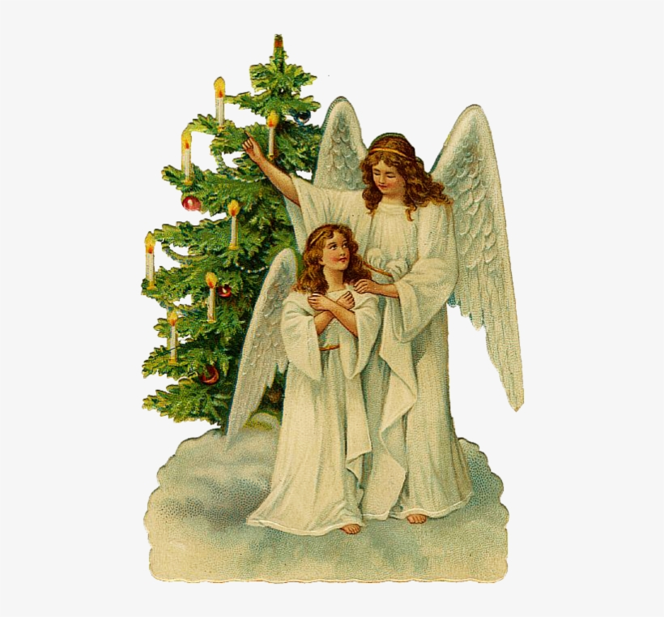
Angels will be available to “pick” from the Angel Tree TODAY! This year, you may shop for the child as usual, or you may give whatever amount of money you would spend on the child in the form of a check payable to CHUMC with the name of your angel written on the check. Then all money will be turned over to Humankind on Wednesday, December 4 so that their staff can shop for your child. They will return the gifts to us on December 13 so that the women of the church can wrap/gift bag them at the UMW luncheon on December 14. If you are giving money rather than shopping, please turn it in to church by Sunday, December 1.
There will be a sheet by the Angel Tree to sign up what angel you have taken and whether you are shopping or giving money.
Humankind is depending on us to be the major provider of Christmas for these children, so thank you so much for your generosity!
~Judy Robertson
Meals on Wheels
Monday, November 4 ~ Judy Lease, Eleanor Maxham
Tuesday, November 5. ~ Judy and Dan Robertson
Wednesday, November 6. ~Linda Jessen, Ruth Ann Harris
Thursday, November 7. ~No Driver
Friday, November 8. ~Betty Taylor, Jane White

**This Week’s Calendar**

Sunday, 11/3 | 11:45 a.m. | Annual Charge Conference
 | 3:00 p.m. | Cantata Rehearsal @ Timberlake UMC
Tuesday, 11/5 | 9:00 a.m. | Prayer Group
 | 10:00 a.m. | Homeschool First
 | 10:30 a.m. | Bible Study
 | 6:00 p.m. | Neighborhood Watch
Wednesday, 11/6 | 5:30 p.m. | Park View Missions Dinner  If you have not been asked to help, but would like to come and share in the meal and visit with the attendees, anyone is welcome.
Thursday, 11/7 | 6:00 p.m. | Handbells
 | 6:45 p.m. | Choir
Friday, 11/8 | 9:00 a.m. | Homeschool First
** Looking Ahead on the Calendar **
Wednesday, 11/13 | 10:00 a.m. | Merry Martha’s @ CHUMC  Sue Norvelle and Pat Short will host. Pat will present a program on the World Thank Offering.
Read Ahead
November 10, 2019 ~ Veterans Sunday. The Scripture is 1 Thessalonians 2:13-17. The sermon text is Luke 20:27-38 and the message is “Heaven”.
In the Grocery Cart This Month
For NOVEMBER: We will collect food for Thanksgiving: “cranberry sauce, corn, green beans, yams; jars of gravy, boxed stuffing, and boxed cornbread mix. In the Hygiene room we are in need of body wash for men and women and body lotion. Please feel free to donate any other hygiene products.” Place donations in the grocery cart, located in the Commons. **NOTE: Please put all liquids in the box provided. Tape down all flip top bottles.
Churches for Urban Ministry Citrus Sale
Deadline for orders is TODAY. Order forms are placed in the Commons. For more information contact Tammy Balderson or Eleanor Maxham.

Slavery Must Be Singular
“Jesus said that you cannot serve God and money. We cannot have God as the Lord of our life and also be a slave to materialism… Jesus did not say, ‘You should not serve both God and money’… Nor did he say, ‘you must not’… He said, ‘You cannot serve both God and money.’ In other words, he is saying, ‘I’m not giving you advice. I’m saying it is impossible. It is impossible for you to become a slave to both.’ [Poverty or Prosperity—Which Is Biblically Correct? ~John Maxwell]

2019 Christmas Angel Tree Program
Angels will be available to “pick” from the Angel Tree TODAY! This year, you may shop for the child as usual, or you may give whatever amount of money you would spend on the child in the form of a check payable to CHUMC with the name of your angel written on the check. Then all money will be turned over to Humankind on Wednesday, December 4 so that their staff can shop for your child. They will return the gifts to us on December 13 so that the women of the church can wrap/gift bag them at the UMW luncheon on December 14. If you are giving money rather than shopping, please turn it in to church by Sunday, December 1.
There will be a sheet by the Angel Tree to sign up what angel you have taken and whether you are shopping or giving money.
Humankind is depending on us to be the major provider of Christmas for these children, so thank you so much for your generosity!
~Judy Robertson
Meals on Wheels
Monday, November 4 ~ Judy Lease, Eleanor Maxham
Tuesday, November 5. ~ Judy and Dan Robertson
Wednesday, November 6. ~Linda Jessen, Ruth Ann Harris
Thursday, November 7. ~No Driver
Friday, November 8. ~Betty Taylor, Jane White

